Pear Tree Sample Winter Menu

Week 4 | Monday | Tuesday | Wednesday | Thursday | Friday
Breakfast | A choice of cereal and toast | A choice of cereal and toast | A choice of cereal and toast | A choice of cereal and toast | A choice of cereal and toast
Allergens | Cereals containing gluten. Milk | Cereals containing gluten. Milk | Cereals containing gluten. Milk | Cereals containing gluten. Milk | Cereals containing gluten. Milk
Morning snack | A choice of fresh fruit | A choice of fresh fruit | A choice of fresh fruit | A choice of fresh fruit | A choice of fresh fruit
Allergens
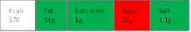  Lunch | 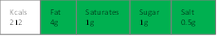  Creamy Chicken Korma served with white rice and warm nan bread. Side dish of seasonal veg. | 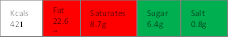  Haddock topped with a tomato and hidden vegetable sauce served on a bed of rice and green beans | 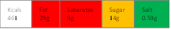  Mince and tatties served with carrots and peas | 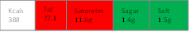  Courgette and mozzarella vegetarian lasagne with carrot and cucumber sticks and tomato bread | Steak pie served with new potatoes and seasonal vegetables
Allergens | Cereals containing gluten, Milk | Fish |  | Cereals containing gluten, Milk | Cereals containing gluten, Milk
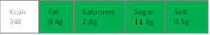  Afternoon snack | 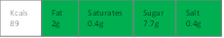  Slow cooked bolognaise sauce served with spaghetti with mixed vegetan | 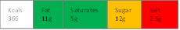  Butternut squash, sweet potato and seasonal veg Soup with crusty homemade bread with melted mozzarella | 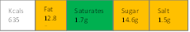  Slow cooked chicken and bean casserole with creamy mash and seasonal vegetables | 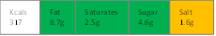  Homemade cheese, tomato and sweetcorn pizza | Fish cakes with homemade baked beans
Allergens | Cereals containing gluten, Milk | Cereals containing gluten | Milk | Cereals containing gluten, Milk | Cereals containing gluten, fish

